NORTH AMERICAN BANDING COUNCIL

PROMOTING SOUND AND ETHICAL BANDING PRINCIPLES AND TECHNIQUES

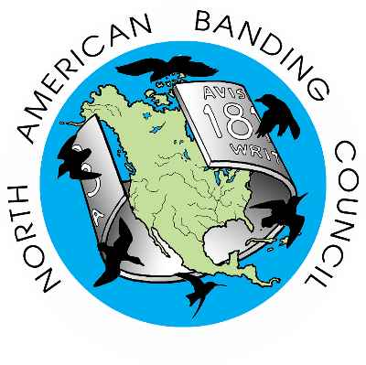

THIS BANDING STATION IS OPERATED AND RUN ACCORDING TO THE GUIDELINES ISSUED BY NABC
UNDER A BANDER WHO HAS BEEN CERTIFIED BY THE

NORTH AMERICAN BANDING COUNCIL

Name
Year of certification

For more information on NABC visit the NABC webpage at

WWW. NABANDING.NET

